**Timecard Portal Application & Submission**

* Intranet portal page**:** [**http://talent.capgemini.com/in/**](http://talent.capgemini.com/in/)
* Under ACCESS ALL TAB Usefool Tools: **Time Card Application**

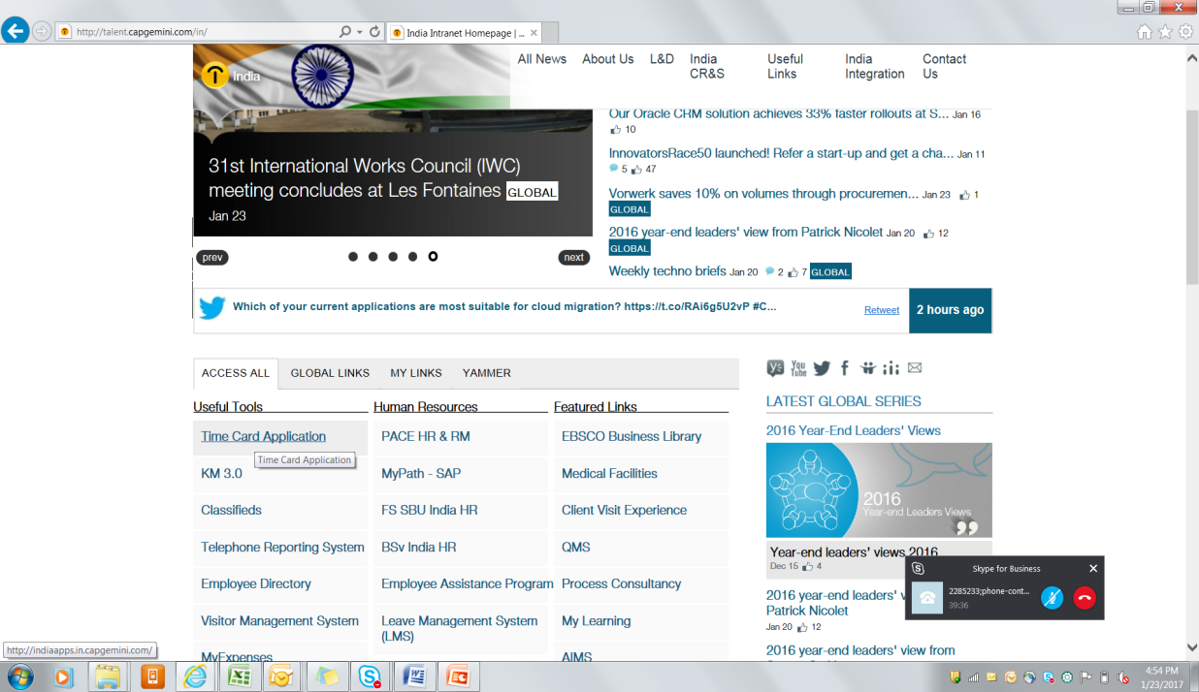

* **To Submit Timesheets > Under FINANCE Tab > Timecard > Timecard Summary**

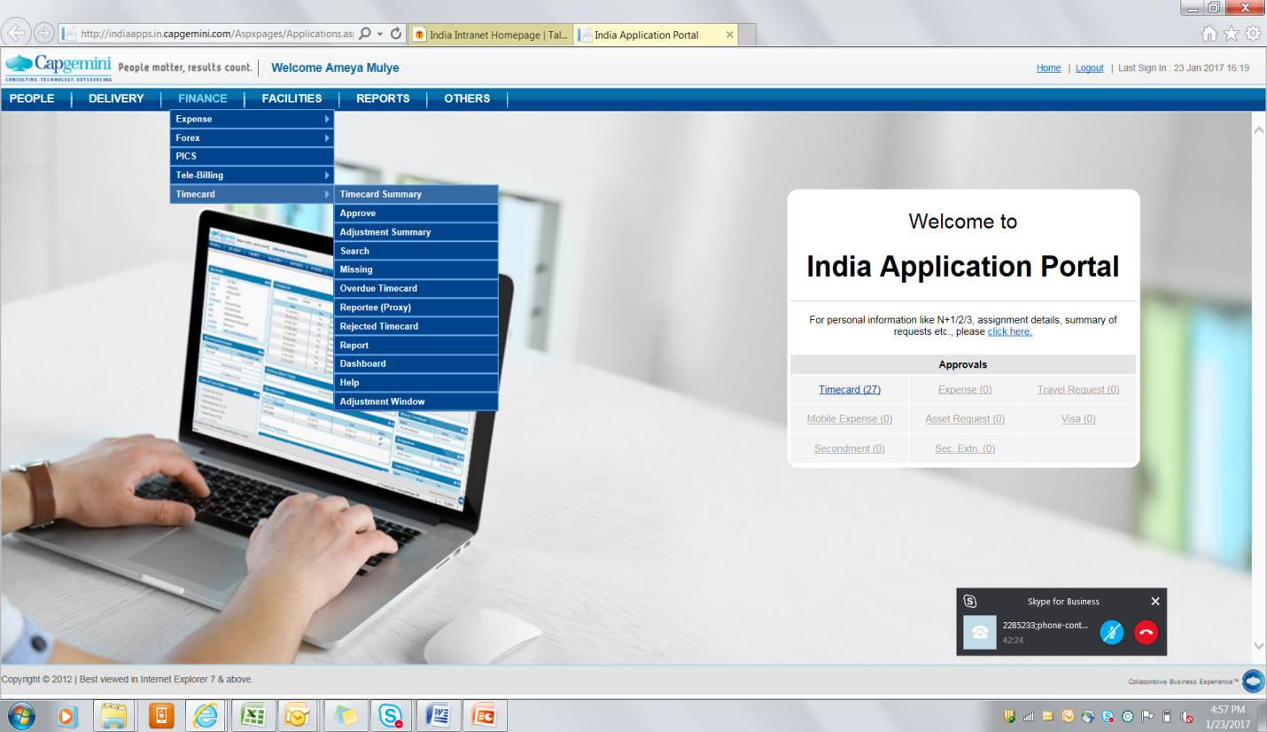

**Ex. Submitting timecards**

Use the code on which resource tagged and apply leaves as well if it’s planned & approved in the system so accordingly you can submit timecard accordingly.

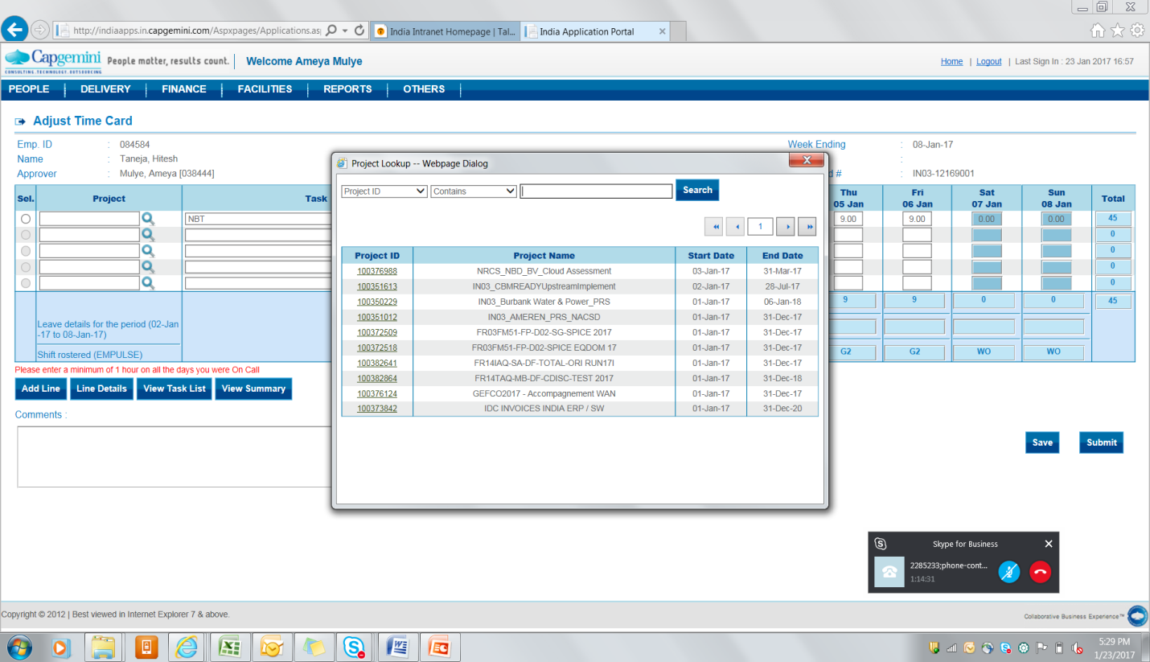

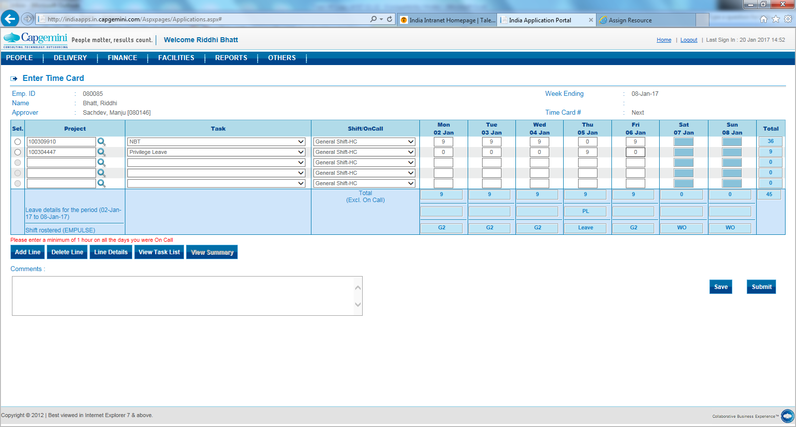

**Adjusting Timecards**

* Intranet portal page**:** [**http://talent.capgemini.com/in/**](http://talent.capgemini.com/in/)
* Under ACCESS ALL TAB Usefool Tools**:** Time Card Application > FINANCE > Timecard > Adjustment Summary Tab > Selecting correct Emp Cod/Weekending/month

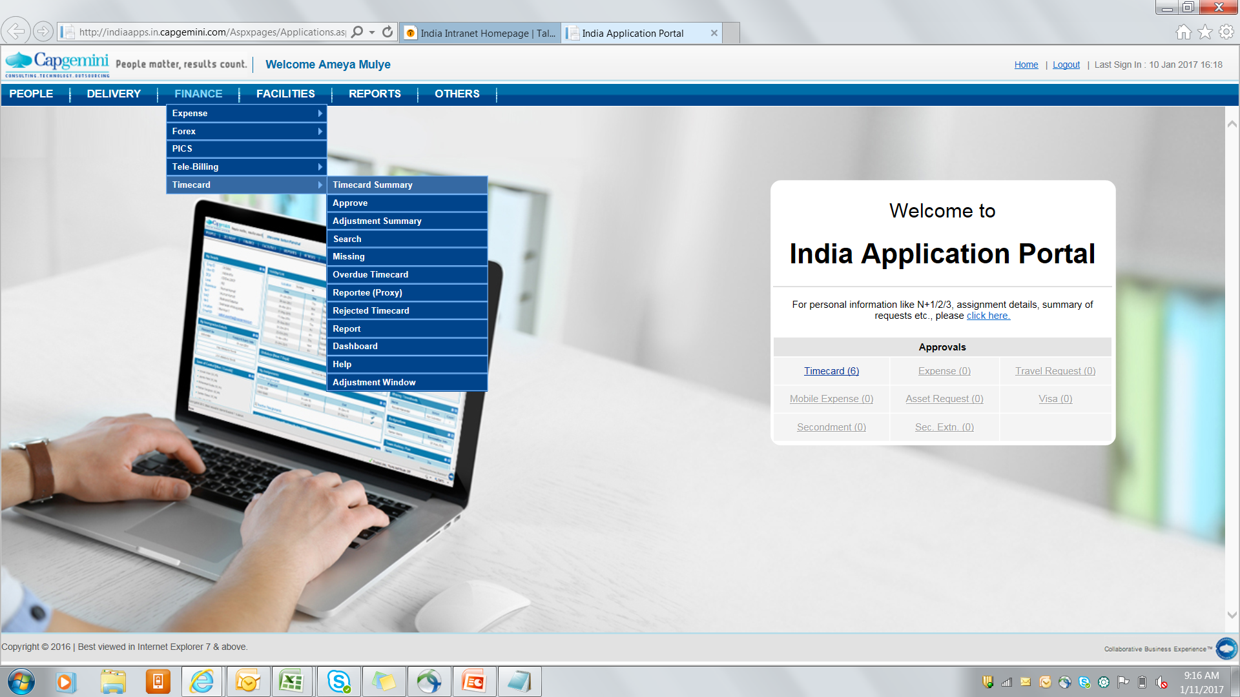

**NBT codes: Public Holiday 100304473 leave code 100304447 Bench Code: 100309766**

**Shadow code 100309767 Long Leave code 100309765 Shadow SWA Code: 100252377**

**Campus Hire Code 100309769 Training Code 100309751**